Save the On-line application.

Our current on-line SAR application process is a work in progress that is intuitive to the 30-50 year-old applicants with minimal guidance, they are working well with the on-line application. They are finding the application on the SAR web site and filling in the data on their own.

Our long-time registrars and other compatriot assistants in preparation of an SAR application have “never done it that way before” and are happy with the “PDF” version application, or the $30 Cox application system or even an MS Word version that has been recently built by our current Genealogist General. These alternatives have one major flaw, they are not readily available on line to new applicants; a new applicant must go through an SAR state membership chairman who funnels them to worthy compatriot who must then send the application form to the new applicant to complete and then the applicant may initiate the process of back and forth e-mail or snail mail.

As our state web master, my 30-year-old son, has made the point to me that when he is working with our fellow compatriots on the state web site, he believes the SAR is auditioning for the third version of the 1993 movie “Grumpy Old Men” starring Walter Matthau and Jack Lemon. Many of our long time compatriots have never had to deal with on-line computer activities and are uncomfortable with using a new approach.

As of now, when you complete the on-line application, you still have to print the application and mail it in to the state registrar with the paper copies of the evidence and the required fees. There currently is no place to upload the supporting documents nor pay the application fee.

Someday, when all is computerized, a back-up copy will be maintained on a computer database and all evidence/proof will be sent electronically to the staff genealogist at Louisville. That day is far in the future.

There are three benefits to accomplishing this using the on-line application:

- Computer literate applicants can access the on-line application and initiate their application at their leisure.
- The on-line application can be simultaneously edited for accuracy by the individual, the chapter registrar, the state registrar and the state president at this time.
- Once the accurate data is in place, it goes into a holding space with an assigned "ACN" number that someday will be imported into the general SAR Genealogical Record System (GRS) that will allow future applicants to review the data to see how they might connect to the original patriot. That part of the system appears to be years away because in the SAR we "have always done it another way!"

The individual state societies must identify an Information Technology Point of Contact (POC) with the National IT Committee Vice Chair, Bill Marrs, (mailto:mSARTechTX@gmail.com) The state POC then has the capability of granting access to the state and chapter registrars to view applications at their respective levels.

In September 2016, about 37% of North Carolina applications are coming through the on-line process. That is because some of our more energetic registrars are learning to use the system and complaining to the IT committee at SAR Headquarters about stumbling blocks. So far, this process has helped fix some obvious flaws. The concept of adding electronic proof to the applications has been brought to the national SAR IT committee and has been dismissed as being too much, too soon.

North Carolina may be more advanced in using the on-line system than the rest of the nation.

We, in North Carolina, have proceeded beyond the concept that the new on-line version of the SAR application is flawed. (a disaster in some eyes) It is yet another version of the computer generated forms that are so fondly thought about in our society.

Someday, as we gradually develop a Genealogical Record System (GRS) we will want to digitize our applications to allow us to use them as sources for future applicants. We will hire volunteers or pay for someone to duplicate the applications and allow those folks to make mistakes. In my own case, I have ancestors who lived in Otego, in Otsego County in New York. With one keystroke, this could result in them living in Otsego, in Otsego County in New York which is a perfectly acceptable location but entirely different. I KNOW the difference. Does the one who might digitize my application?

As with any of the other programs that are very respected, an application must be completed using a computer program (Hand written applications are no longer in vogue!) The application must then be printed on approved paper and referenced documentation added to prove each generation’s authenticity. The “new” online version does the same with the added benefit that the digital application is stored for future use and can be simultaneously seen by chapter and state registrars and the applicant as inputs are made. Changes can be made at every level.

In North Carolina, our state registrar has tried to “break the system” and has offered numerous suggestions for improvement to the online application. Our limitation is that the programmers, Blackstone, cannot make the changes unless they have Trustee approval to pay for the upgrades.

Every compatriot should be able to set up an account. Every applicant should also be able to set up an account using these steps.
To setup a new account, first go to https://www.sar.org. You will see this screen. Click on “Login”.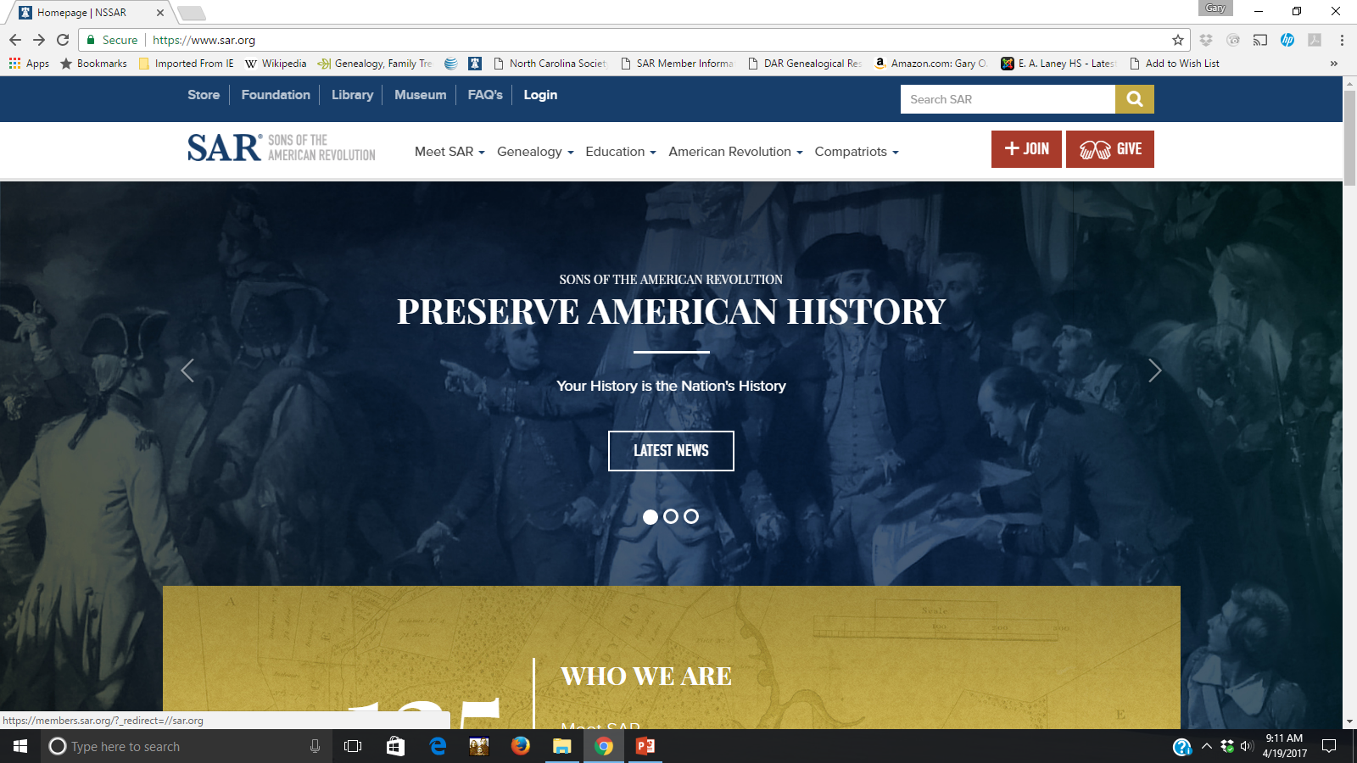
Figure 1
You will be taken to the Log In/Sign Up screen. If you don’t already have an account. Click on the “Sign Up” tab.
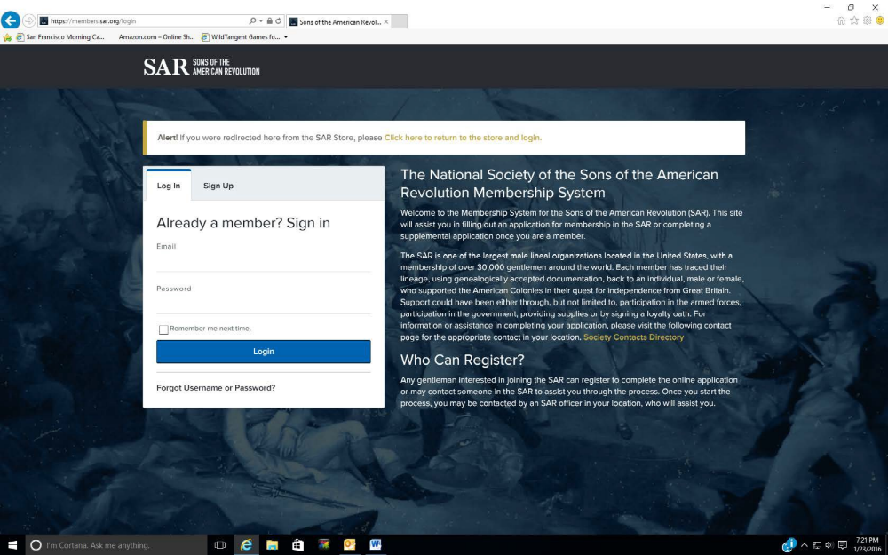
Figure 2

To create a new account so you can prepare membership applications or register for SAR events, you must first sign up. Click on the “Sign Up” tab on the screen above and this screen will appear. Enter you first and last name, your email address, a password and a password confirmation (this password will be needed for all future logins). Then click on the blue “Sign Up” button. Once this is done, logoff and don’t log back in until the next step is completed. NOTE: it is very important that your email address is entered correctly since the address will be used to send back an email from the NSSAR to confirm and complete your registration.
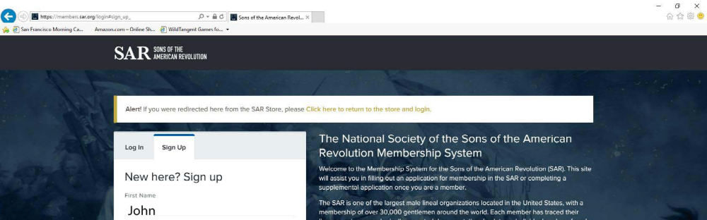
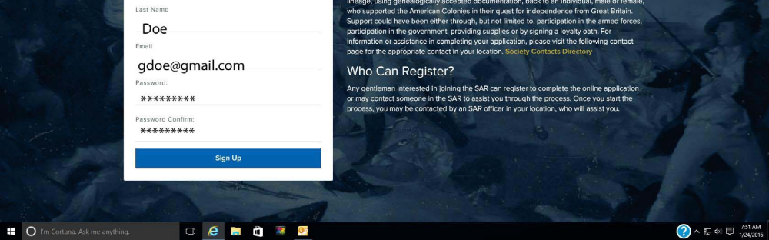
Figure 3
Once you submit this sign-in information, you will be sent an activation email from the Sons of the American Revolution like the one below. Click on the link “Please click to activate account” link. Wait until this email is received before proceeding. If the activation email is not received within a few minutes, be sure to check your junk or spam mail folders.
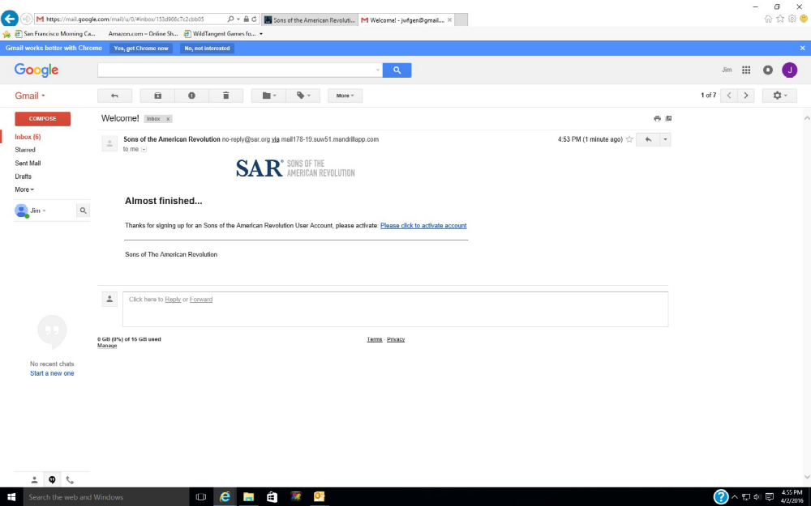
Figure 4
Clicking on the link in the email will returned you to the SAR login page where you now enter your email address and the password you selected and click on the blue “Login” button. Once you’ve logged in, you will be taken to your personal “dashboard” screen.

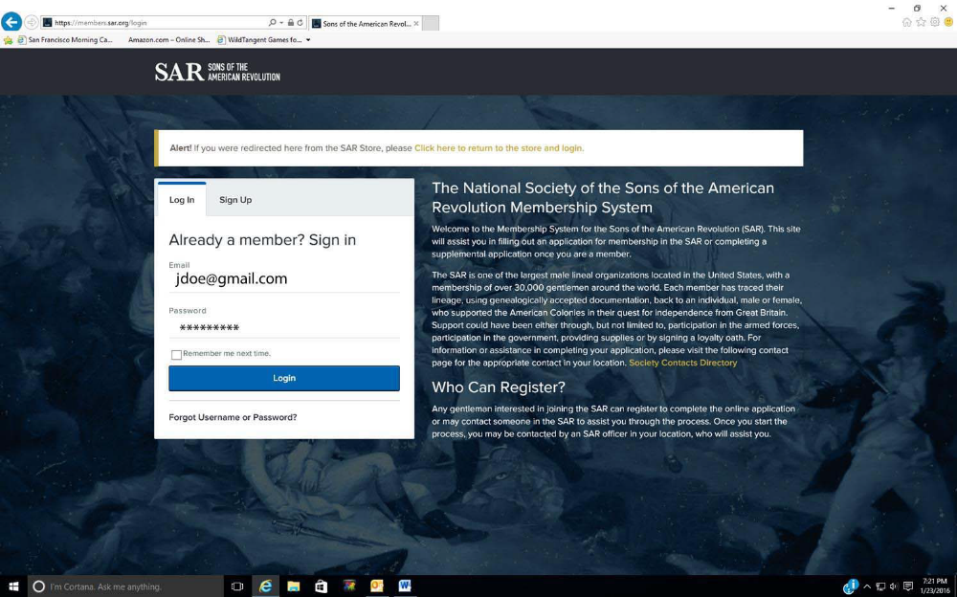
Figure 5
You will be taken to a personal dashboard screen. Note there are three options on the left; SAR Website, My Applications, and Events.
On the top right is “View/Change Profile”. To complete the initial setup, click on the “View/Change Profile” link.
Note: If you don’t see the three options and only the icons on the left, hold down the “Windows” or “Apple” key and press the minus “-” key to change the webpage resolution.

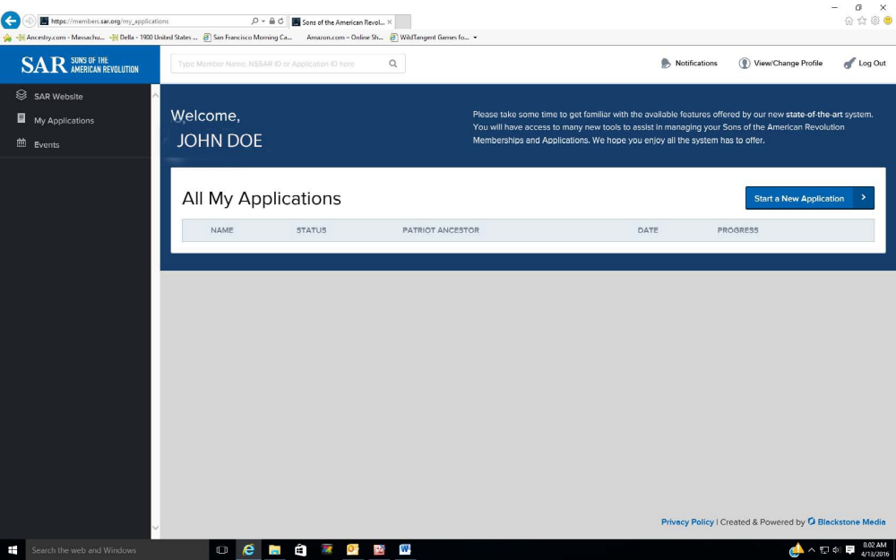
Figure 6
This screen will come up to allow completion of the setup. Click on the “Search for your NSSAR #” button. Do not fill in any other information at this point. A search box for your NSSAR # will be appear (next page). DO NOT fill in any of the other fields.

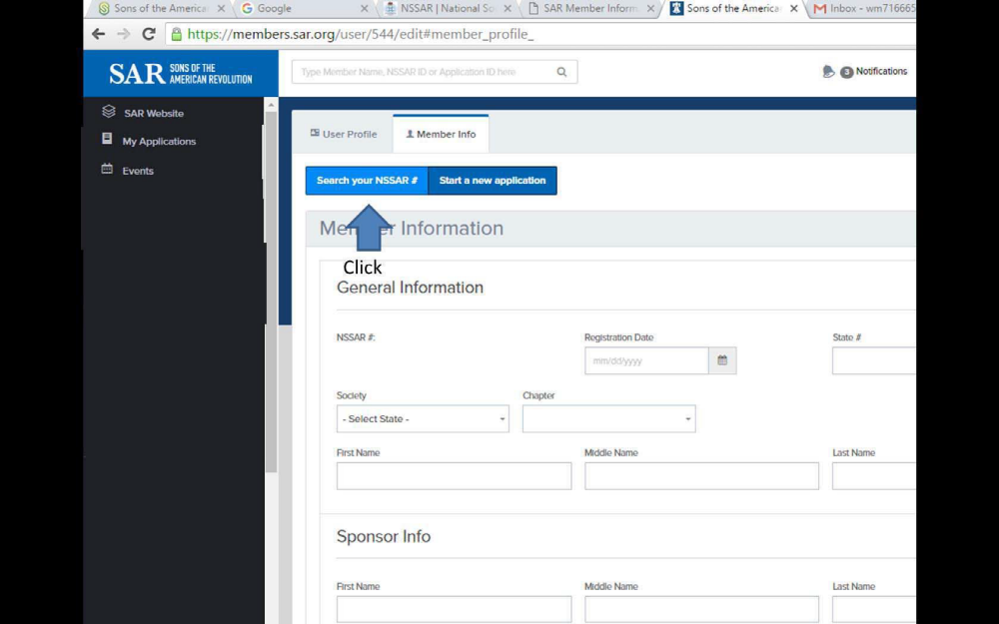
Figure 7
This screen will appear next. Enter your National SAR Number. When you enter your National Number and press “Enter”, the next screen will appear to verify your name.

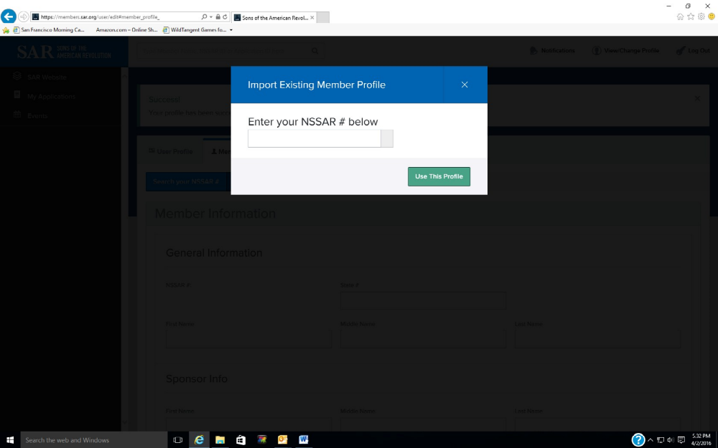
Figure 8
When you enter the NSSAR number on the previous screen, the information from the SAR Member Database will populate this screen.
With your name, State Society, and State Number. If this is you, check the acknowledgement box and click the “Use this Profile” button to activate your account.
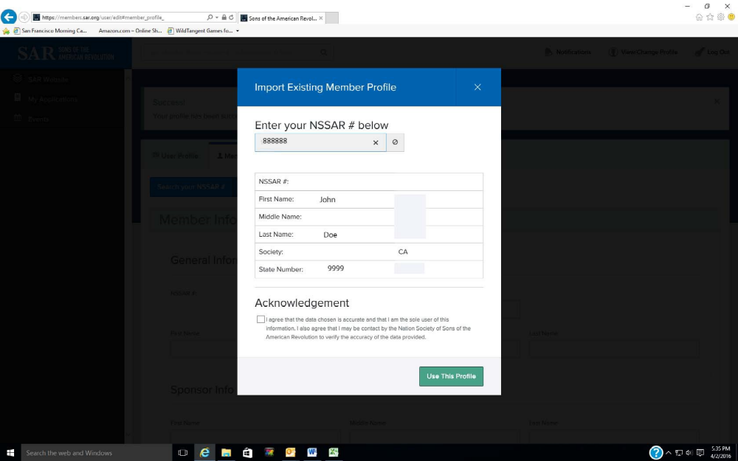
Figure 9
Once the account is activated, whenever you log in, the following screen will appear with the default going to the “My Applications” screen. In the left-hand sidebar are three icons with titles for accessing the new SAR website, “My Applications”, and “Events”. Click on the “SAR Website” to go to the new website. The “Events” screen is used for registering for SAR events. Registration for all future events (Leadership Meetings, Congress, etc.) can only accomplished via this screen for online registration. To begin a new or supplemental application click on the “Start New Application” button. If you are a State or Chapter President, Secretary, or Registrar, let your State Secretary or your State IT Point of Contact know since he will have to assign special permissions for your position.
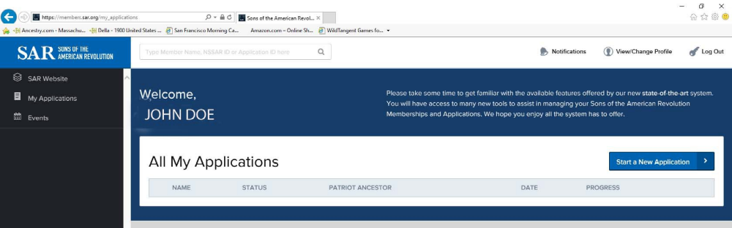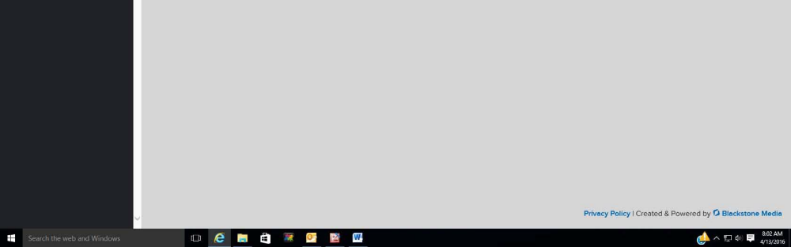
Figure 10
This challenge goes to anyone who is a Trustee. Your vote and input should not be from hearsay evidence that the program is a disaster; it should be from shared knowledge that you have tried to make the program work for you. Input your personal application before you vote during Leadership meeting in the fall.
The challenge to every Compatriot is to fill in an on-line application using your initial application and any approved supplemental applications to have your portion of the GRS already in the system.

We, in North Carolina, have improved from about 37% participation in September 2016 in the online version usage to about 80%. If the flaws that we have identified could be fixed, we might approach the 92% participation enjoyed by another society.

GARY O. GREEN, Lt Col, USAF (Ret)
Secretary/NC SAR IT POC, North Carolina SAR #168757
6720 Creek Ridge Rd
Wilmington, NC 28411-8908
910-612-3676

