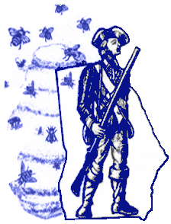
Elijah Clarke and Heroes of the Hornets’ Nest
Remembrance Day

Friday, February 9, 2018
10:30 a.m. - 2:30 p.m.

Elijah Clark State Park
2959 McCormick Highway
East of Downtown Lincolnton, GA

Come when you can.
10:30 a.m. Living history at restored cabin and Elijah Clark Museum-
colonial lifestyle demonstrations - period music –
musket and cannon firings - traveling trunk display- book signings
12:00 p.m. Free chili luncheon and dessert buffet
1:30 p.m. Heroes of the Hornets’ Nest Wreath Ceremony
Noted Army Historian Steve Rauch will be the guest speaker, and regional color guard and militia units will combine to bring pomp and circumstance to the occasion. Compatriot David Noble will reveal new discoveries in his search for Georgia Patriot hero John Dooly’s home and gravesite and other exciting historical findings.
Indoor facilities are available in the event of inclement weather

Special discounts of $105 a night (plus tax) will be offered for
2-night cabin rentals at the park.

Sponsored by the Elijah Clark State Park; Friends of the Elijah Clark Park; Lincoln County Historical Society; William Few and Atlanta Chapters of the Sons of the American Revolution; the Stephen Heard and Elijah Clarke Chapters of the Daughters of the American Revolution ; and the General Nathaniel Greene Chapter Sons of the Revolution.

See attached wreath presentation reservation form.
For questions contact Charlie Newcomer ( canewcomer@att.net or 706 543 3977)

